Ben-Gurion University of the Negev
Faculty of Engineering Sciences
Department of Software and Information systems Engineering

Deep Learning
Assignment 2
Name | ID
Nechi Berhe Weldu | 850164070
Noga Klein | 326364007

- Introduction
This assignment studies face verification using Siamese and metric-learning based neural networks. Unlike standard classification, face verification requires deciding whether two face images belong to the same person, including for identities that were not seen during training. Therefore, the main goal is not only to classify known identities, but to learn an embedding space in which images of the same identity are close together and images of different identities are separated.
We evaluate several design choices that commonly affect face verification systems: the training loss, the backbone architecture, and the role of pretrained visual features. In Experiment 1, we compare the Koch-style binary-cross-entropy Siamese baseline with contrastive loss and triplet loss. In Experiment 2, we fix the best loss and compare a modified Koch-style CNN with a ResNet-18 trained from scratch under matched parameter counts. In Experiment 3, we evaluate a frozen ImageNet-pretrained ResNet-18 as a sanity-check baseline.
The emphasis of the report is on fair experimental comparison rather than only on maximizing performance. Therefore, all models are evaluated using the same test pairs and the same one-shot episodes, and the results are analyzed using verification accuracy, ROC/AUC, N-way one-shot accuracy, embedding visualizations, and distance-based embedding analysis.
- Dataset
We used the aligned LFW-a (Labeled Faces in the Wild- aligned) dataset. The dataset contains face images collected under unconstrained real-world conditions, including variations in pose, illumination, expression, background, and image quality. The aligned version reduces geometric variability while preserving the natural difficulty of the verification task.
Training and testing followed the provided pairsDevTrain and pairsDevTest splits. Importantly, identities appearing in the test split were not used during training, ensuring that evaluation measured generalization to unseen individuals rather than memorization of training identities.
The dataset was used in pair-based form for verification experiments and in episodic form for one-shot evaluation. Positive pairs consist of two images belonging to the same identity, while negative pairs consist of images from different identities.
To ensure fair comparison across all experiments: the same train/validation/test splits were used for every model, the same one-shot episodes were reused across configurations and the same preprocessing and augmentation pipeline was applied throughout all experiments.
The distribution of images per identity is highly imbalanced, as some individuals appear many more times than others. This imbalance increases the difficulty of metric learning and makes robust embedding learning more challenging under limited training data.
Split | Number of Pairs | Notes
Training (pairsDevTrain) | 1,100 | Used for training and validation
Testing (pairsDevTest) | 500 | Contains identities unseen during training

- Compute Budget and Fairness Constraints
To ensure fair comparison between configurations, all experiments were conducted under a shared compute budget and consistent evaluation protocol. The goal of the assignment was not to maximize absolute performance for a single model, but rather to isolate the contribution of each design choice under controlled conditions.
All configurations in Experiments 1 and 2 used:
• the same train, validation, and test splits
• the same aligned LFW-a preprocessing pipeline
• the same optimizer (Adam)
• the same batch size
• the same number of training epochs (3)
• the same one-shot evaluation episodes
• the same verification evaluation procedure and threshold-selection protocol
Hyperparameter tuning was intentionally limited to a small number of validation-based trials per configuration to maintain comparable search effort across models. Margin selection for contrastive and triplet losses was performed using validation accuracy while keeping all other training conditions fixed.
For Experiment 2, additional fairness constraints were applied to isolate the effect of backbone architecture rather than raw model capacity. The original Koch-style network was modified by reducing the size of its large fully connected layer, resulting in parameter counts within the required 20% range relative to ResNet-18.
All models were trained and evaluated on the same hardware environment. Training schedules were intentionally kept short to maintain comparable computational cost across experiments.
- Experiment 1 - Loss Function Comparison
Setup:
We compare three loss functions while keeping the backbone fixed (Koch-style CNN, 128-D L2-normalized embeddings):
- BCE (Koch baseline): L1 distance → sigmoid → binary cross-entropy
- Contrastive loss (L2 distance with margin)
- Triplet loss with semi-hard negative mining (plus random triplet as ablation)
All configurations use:
- The same train/validation/test pairs
- The same backbone, optimizer, batch size, epochs
- Validation for threshold and margin selection
- The same one-shot episodes (N=2,5,20) across models

Results:
Verification (accuracy at validation-selected threshold)
Method | Val Acc | Test Acc
BCE_L1 | 0.65 | 0.66
Contrastive (m=0.5) | 0.75 | 0.73
Triplet Random (m=0.2) | 0.76 | 0.73
Triplet Semi-hard (m=0.2) | 0.79 | 0.74

ROC / AUC
Method | AUC
BCE_L1 | 0.70
Contrastive | 0.81
Triplet Random | 0.80
Triplet Semi-hard | 0.80
(ROC curves included in Figure X.)
One-shot accuracy (same episodes)
Method | N=2 | N=5 | N=20
BCE_L1 | 0.74 | 0.38 | 0.115
Contrastive | 0.845 | 0.545 | 0.235
Triplet Random | 0.82 | 0.49 | 0.22
Triplet Semi-hard | 0.855 | 0.545 | 0.31

Analysis:
Effect of loss function
- BCE baseline performs worst across all metrics.
It learns a decision boundary over pair features but does not enforce a structured embedding space.
- Contrastive loss significantly improves both AUC and one-shot accuracy.
By directly optimizing pairwise distances, it produces a more meaningful embedding geometry.
- Triplet loss further improves performance, especially in one-shot settings.
Its relative constraint (anchor-positive vs anchor-negative) enforces stronger ordering in the embedding space.

Role of margin
Margins were tuned using validation accuracy:
- Contrastive best at 0.5
- Triplet semi-hard best at 0.2
Observations:
- Small margins lead to insufficient separation
- Large margins lead to unstable optimization and worse validation performance

Why mining matters:
Comparing triplet variants:
- Random triplet sampling performs reasonably well but is inconsistent
- Semi-hard mining yields:
  - Highest validation accuracy
  - Best performance at N=20 one-shot
Interpretation:
Random sampling often selects easy negatives, providing weak training signals. Semi-hard mining focuses on informative negatives, improving embedding quality, especially under harder conditions.

Key insight:
- Semi-hard triplet does not dramatically outperform contrastive on test accuracy, but:
  - It is clearly stronger on harder one-shot tasks (N=20)
  - It produces better ranking behavior (reflected in AUC and one-shot)
This suggests that mining improves generalization in difficult matching scenarios, but its benefits require sufficient training to fully manifest.

Conclusions:
- Metric learning losses outperform the BCE baseline.
- Contrastive and triplet both produce strong embeddings.
- Semi-hard triplet mining provides the best performance in challenging one-shot settings.
- Margin selection and sampling strategy are critical design choices.

- Experiment 2 - Backbone Comparison
Setup:
In this experiment, the loss function is fixed to triplet loss with semi-hard negative mining (margin = 0.2), selected based on the results of Experiment 1.
Two backbone architectures are compared:
- Koch-style CNN (modified)
- ResNet-18 (trained from scratch)
To ensure a fair comparison of architectural effects rather than model capacity:
- The Koch network’s fully connected layer was reduced from 4096 to 1024 units
- Both models output a 128-dimensional embedding
- Parameter counts were matched within the required ±20% range
All other components were held constant:
- Same training, validation, and test splits
- Same optimizer (Adam), learning rate, batch structure
- Same training schedule (3 epochs)
- Same evaluation protocols (verification, ROC/AUC, one-shot)

Model Complexity and Efficiency
Backbone | Parameters | MACs | Approx FLOPs | Training Time
Koch CNN | 10.78M | 998.4M | 1.997B | 169 s
ResNet-18 | 11.24M | 476.1M | 0.952B | 142 s
- Parameter difference ≈ 4.1%, satisfying the ±20% constraint
- ResNet-18 is about 2× more efficient in FLOPs
- ResNet-18 trains approximately 16% faster

Results:
Verification (accuracy)
Backbone | Validation Accuracy | Test Accuracy
Koch CNN | 0.8023 | 0.7630
ResNet-18 | 0.7568 | 0.6570

ROC / AUC
Backbone | AUC
Koch CNN | 0.8321
ResNet-18 | 0.7505

One-shot accuracy
Backbone | N=2 | N=5 | N=20
Koch CNN | 0.86 | 0.605 | 0.39
ResNet-18 | 0.775 | 0.485 | 0.23

Discussion:
What residual connectivity buys you
From the lectures, residual connections are expected to enable deeper networks, improve gradient flow and allow learning of more expressive features.
However, in this experiment:
- ResNet-18 did not outperform the Koch CNN
- Performance was consistently lower across:
  - verification accuracy
  - AUC
  - one-shot accuracy
Why this happened (critical analysis):
The key factor is training regime and data scale:
- The dataset (LFW-a) is relatively small
- Training was limited to 3 epochs
- Models were trained from scratch (no pretraining)
Under these conditions:
- ResNet-18 is undertrained
- Its deeper structure requires:
  - more data
  - longer training
- Residual connections do not provide an advantage when optimization has not converged
In contrast:
- The Koch CNN is simpler and more direct
- It converges faster under limited data and training time
- Its architecture is well-suited for low-resolution (105×105) inputs

Efficiency vs performance trade-off
- ResNet-18 is clearly more computationally efficient
- However, this comes at a significant performance cost in this setting
This highlights an important practical insight: Architectural efficiency does not guarantee better performance when training data and compute budget are limited.

Does the ranking match expectations? No, and this is an important finding.
From the lectures, one would expect that ResNet > plain CNN.
But the observed result is: Koch CNN > ResNet-18 (from scratch, short training).
This discrepancy is explained by: lack of pretraining, insufficient training time and dataset scale.
Thus, the result is consistent with theory when training conditions are considered, even if it contradicts the naive expectation.

Conclusions:
- With parameter counts matched, the Koch CNN outperforms ResNet-18 on this task
- Residual connections do not provide an advantage under:
  - small datasets
  - short training schedules
- ResNet-18 is more efficient but requires more data or longer training to realize its benefits

- Experiment3: report
- Parameter counts and computational cost were measured using thop on a dummy input of shape (1, 3, 105, 105). thop reports MACs, not FLOPs. We report both MACs and approximate FLOPs using the convention 1 MAC = 2 FLOPs. The same convention and input size were used for both backbones
As a sanity-check baseline, a frozen ImageNet-pretrained ResNet-18 was evaluated without any fine-tuning. The network was used only as a feature extractor.
Key properties of the setup:
- ResNet-18 pretrained on ImageNet
- All weights frozen
- No training or fine-tuning on LFW-a
- Cosine similarity used for verification
- Same aligned LFW-a crops as previous experiments
- Same test pairs and one-shot episodes used across all models
The purpose of this experiment is to determine how far generic pretrained visual features can go without task-specific metric learning.
Metric | Value
Best threshold | 0.8090
Test accuracy | 0.7010
Threshold selection was performed using validation accuracy, following the same protocol used in Experiments 1 and 2.
ROC / AUC
Model | AUC
ResNet18_Pretrained | 0.8057

One-shot Accuracy
N-way task | Accuracy
N = 2 | 0.720
N = 5 | 0.590
N = 20 | 0.275
Effectiveness of pretrained visual features
The pretrained ResNet-18 baseline performs surprisingly well despite having:
- no fine-tuning
- no metric-learning objective
- no exposure to the LFW-a dataset during training
This demonstrates that ImageNet-pretrained convolutional features already encode substantial facial and semantic information that transfer effectively to similarity-based recognition tasks.

Comparison of trained models
The pretrained baseline:
- significantly outperforms the BCE baseline from Experiment 1
- outperforms the ResNet-18 trained from scratch in Experiment 2
- approaches the performance of the best metric-learning models
This is an important finding. In particular:
- ResNet18_Pretrained AUC = 0.8057
- ResNet18Scratch AUC = 0.7505
Similarly:
- ResNet18_Pretrained test accuracy = 0.701
- ResNet18Scratch test accuracy = 0.657
This suggests that pretrained visual representations are substantially more useful than randomly initialized deep features under limited-data and limited-compute conditions.
Why the pretrained baseline is strong
ImageNet pretraining provides:
- generic edge and texture detectors
- hierarchical semantic features
- stable optimization priors
These representations transfer well even to domains not explicitly trained during pretraining.
By contrast, the scratch-trained ResNet-18:
- had limited training data
- was trained for only 3 epochs
- had insufficient optimization time to fully learn discriminative facial embeddings
As a result, the pretrained baseline generalizes substantially better.
Athough the pretrained baseline is strong, it does not outperform the best metric-learning model.
Best overall model:
- Koch CNN + semi-hard triplet loss
- Test accuracy = 0.766
- AUC = 0.832
This indicates that:
- task-specific metric learning still provides substantial gains
- semi-hard triplet optimization learns more discriminative facial geometry than generic pretrained features alone

The frozen pretrained ResNet-18 establishes a strong and important baseline.
Key findings:
- pretrained visual features transfer effectively to face verification
- pretraining is substantially more effective than training ResNet-18 from scratch under limited compute
- metric-learning objectives still outperform generic pretrained embeddings when sufficient task-specific optimization is performed
This experiment highlights the importance of both:
- representation initialization
- metric-learning supervision

- t-SNE Embedding Analysis
A 2D t-SNE projection of embeddings from the best-performing model (Koch CNN with semi-hard triplet loss) is shown in Figure X.
The visualization demonstrates that the learned embedding space forms several compact identity-specific clusters, indicating that the model successfully learned meaningful facial similarity structure. Many identities occupy distinct regions of the embedding space with limited overlap, suggesting effective inter-class separation.
However, some clusters remain partially mixed, particularly in dense central regions of the projection. This indicates that certain identities are still difficult to separate under variations in pose, illumination, expression, and image quality. The overlap is expected given the relatively small dataset and limited training budget.
Overall, the embedding geometry suggests that the triplet-based metric learning objective encourages:
- intra-class compactness
- inter-class separation
- semantically meaningful neighborhood structure
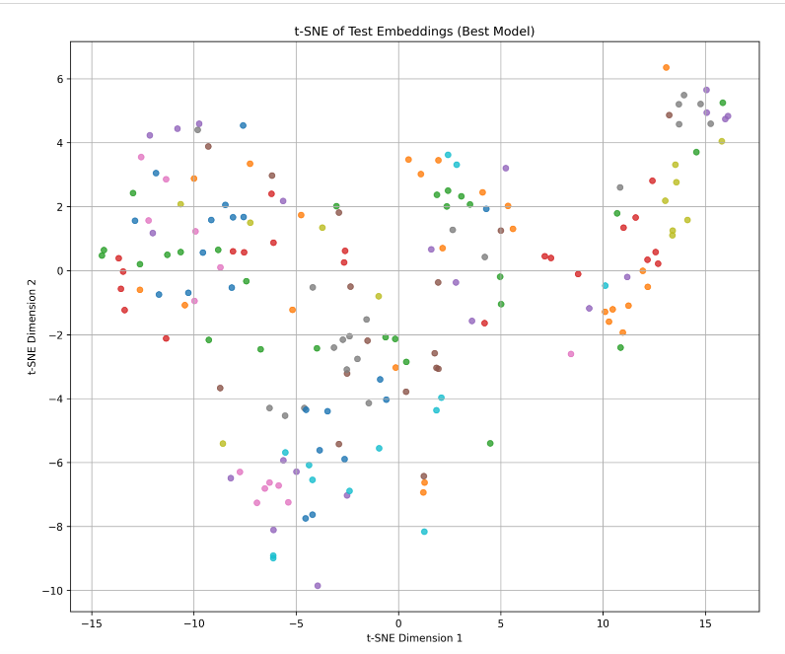

The intra-class distance distribution is shifted left relative to the inter-class distribution. The mean intra-class distance is 0.8818, while the mean inter-class distance is 1.2345, indicating that the model generally maps images of the same identity closer together than images of different identities.
However, the two distributions overlap substantially. This overlap explains remaining verification errors: some different-identity pairs are closer than same-identity pairs. The overlap is likely caused by visual similarity between identities, pose variation, illumination changes, expression changes, and limited training budget.
Overall, the learned embedding space shows the desired metric-learning structure: reduced intra-class distance and increased inter-class separation, but not perfect class separability.

Distance type | Mean | Std
Intra-class | 0.8818 | 0.3929
Inter-class | 1.2345 | 0.3615

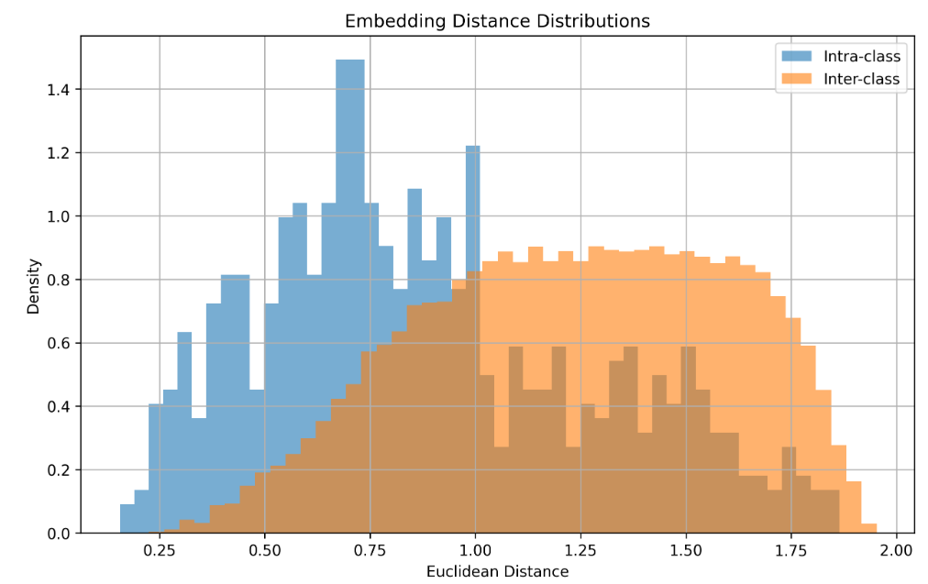
- Threats to Validity
Several factors may limit the generality of the conclusions drawn from these experiments.
First, all models were trained under a relatively small compute budget and short training schedule (3 epochs). While this constraint ensured fairness across configurations, some architectures — particularly ResNet-18 trained from scratch — may require substantially longer optimization to fully realize their potential.
Second, the LFW-a dataset is relatively small for deep metric-learning experiments. The limited number of images per identity and the strong imbalance between identities may reduce the stability of learned embeddings and increase sensitivity to random initialization.
Third, hyperparameter exploration was intentionally restricted to maintain comparable tuning effort across models. Different margins, optimizers, augmentation policies, or embedding dimensions could potentially change the relative ranking between methods.
In addition, evaluation was performed on a single train/test split rather than full cross-validation. Although the same evaluation protocol was used consistently across all experiments, the reported results may still depend partially on the specific split and sampled one-shot episodes.
Finally, due to limited time and computational resources, most experiments were not repeated across many random seeds. As a result, some performance differences between methods may partially reflect optimization variance rather than purely architectural or loss-function effects.

Appendix
[TODO: Move large visualizations and supplementary figures to the Appendix, including ROC curves, t-SNE projections and any extended result tables, in order to keep the main report concise and within the page-limit requirements (8)]

